Justin Wong (jujwong)  
CMPE 150/L  
Katia Obraczka  
January 24, 2016

Lab 1: Installing and Using Mininet

1. After setting up the 4 hosts with 1 switch

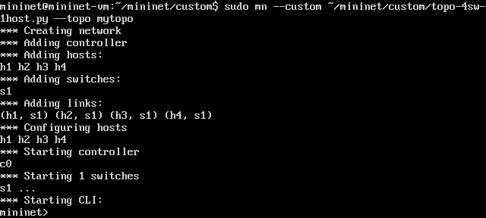

1. The dump command and pingall command:

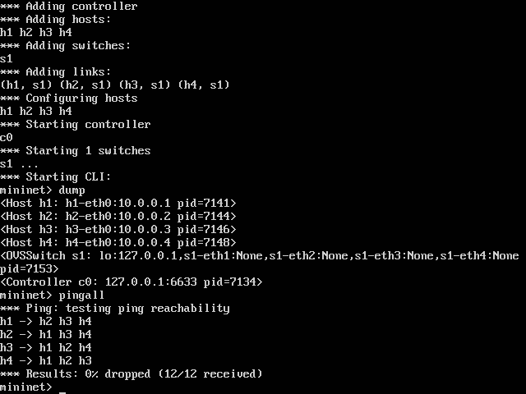

1. iperf command gave me a connection speed of 22.7 Gb/sec



1. After running wireshark:

4b. The command “h1 ping ­-c 5 h2” had 5 of of_packet_in messages.

4c. The of_packet_in has 4 different sources, 2 being 10.0.0.2 the host that the ping was sent to. The destination is either the host sources or host destination. For OFT_PACKET_OUT the source and destination is the ip address of the virtual machine, this was found by clicking on the of_packet_out and looking at the header information.

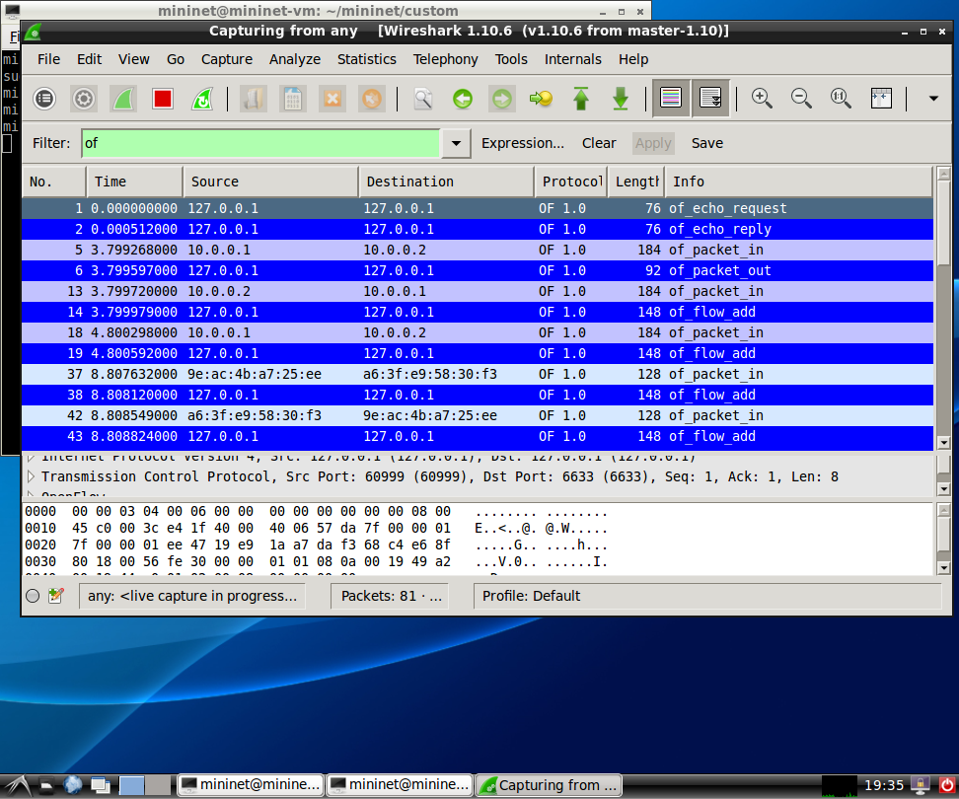

4e. After changing the filter to “icmp && not of”

There were 161 entries generated by Wireshark. There were two types of icmp messages, “Echo (ping) request” and “Echo (ping) reply”